Perform Normalization for NF1,NF2 and NF3

**1NF** - A relation is said to be in 1 normal form in DBMS (or 1NF) when it consists of an atomic value.

**2NF**­- When a table is in 2NF, every non-key attribute is fully dependent on primary key. The Second Normal Form eliminates partial dependencies on primary keys.

The below table is not in 2NF form.

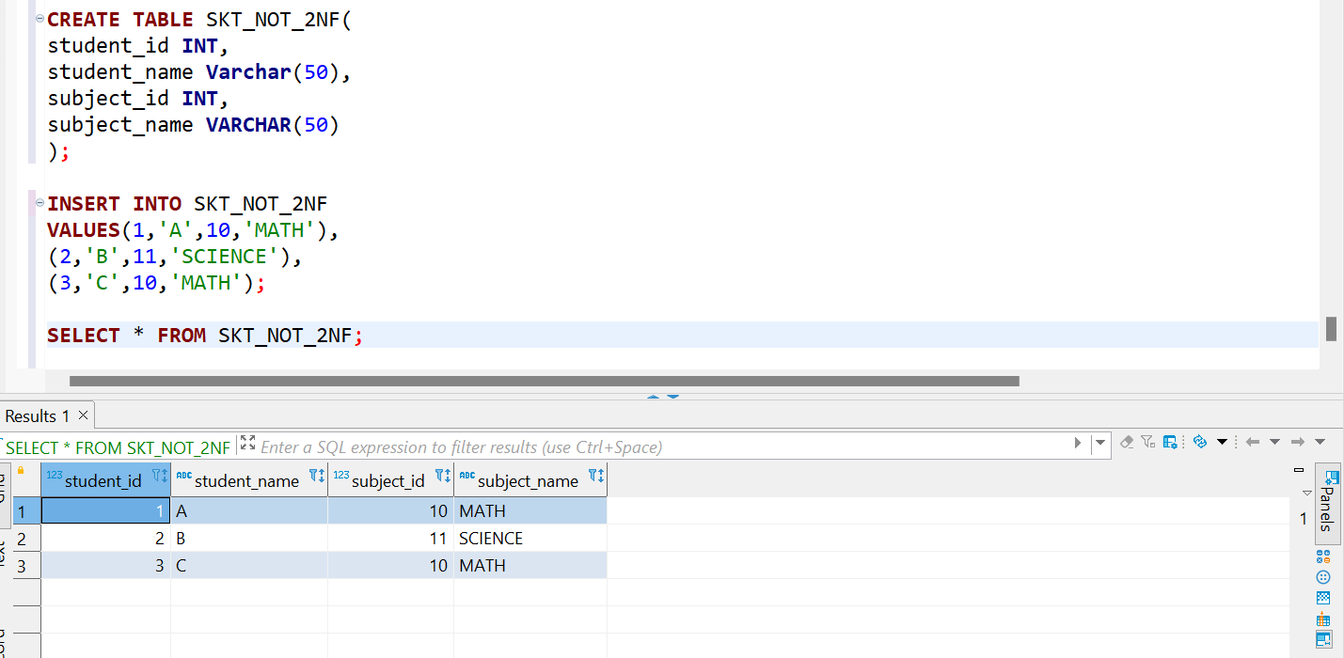

The below tables are in 2NF form

**3NF** - A relation will be in 3NF if it is in 2NF and not contain any transitive partial dependency.

The below table is not in 3NF form

The below tables are in 3NF form

